**INDR421 HW#7, Prepared by Arda Kırkağaç, 49799.**

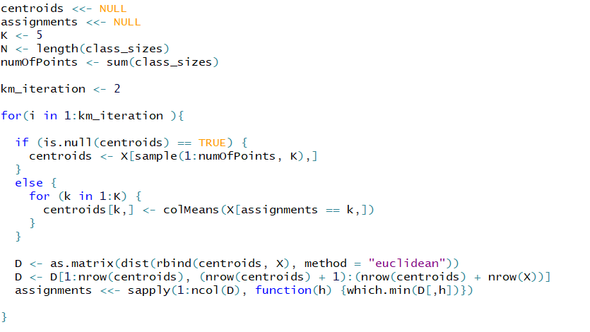In this homework, our goal was to employ an Expectation-Maximization (EM) algorithm, whose mean values are initiated by k-Means algorithm. The bivariate Gaussian data is generated using mvrnorm as usual. K-Means algorithm code is below, it basically randomly chooses five points from our input data, and then iterates the algorithm two times:

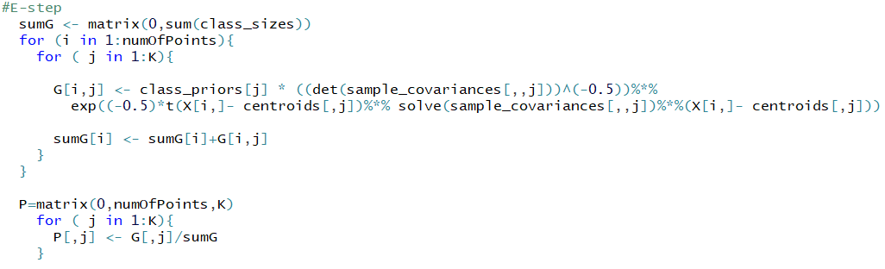I defined N as the length of class sizes, which is different from my previous assignments. Before we use EM algorithm, we first need to initiate multivariate gaussian random variables four our 5 clusters whose means are already calculated by k-Means algorithm. The covariance matrices, however, needs to be calculated from the sample data. After initialization, the iteration is run until 100 iterations are completed. Below you can see the E-step:

Using calculated h values in E-step, we can proceed to M-step, where the means and covariances are updated accordingly to prepare for the next E-step:

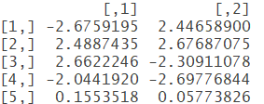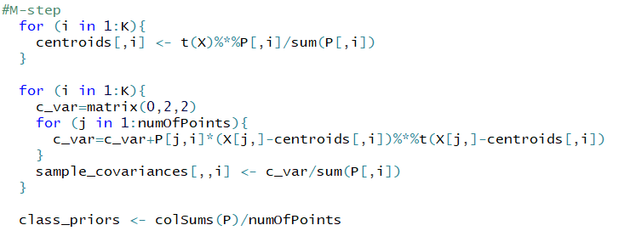

After 100 iterations, you can see the resulting mean matrix for gaussians on the right, which is identical to the matrix in the document, with index differences:

After plotting points, and finding 0.05-density curves for each Gaussian using ellipse() function, resulting plot is below:

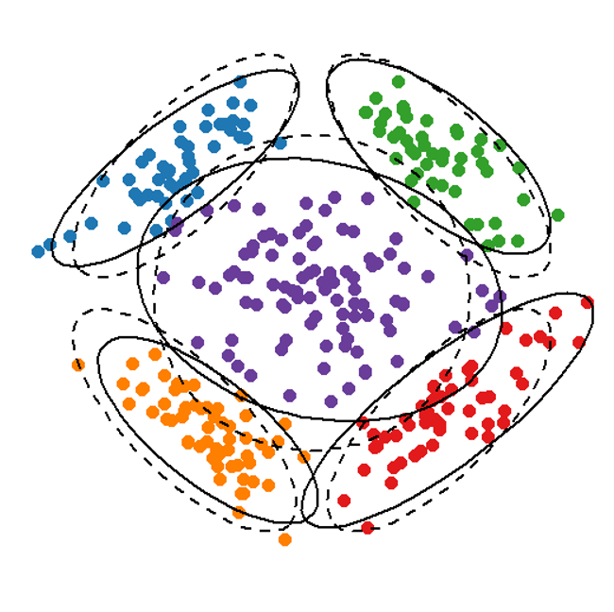6

0

6

-6

0